March 2015

Dear Family,

Beginning April 11, students in grades 3-5 will be taking a revised state assessment. The Michigan Student Test of Education Progress (M-STEP) was developed in 2015 to replace the 44-year-old MEAP test. M-STEP is aligned to Michigan’s challenging learning standards, and includes fewer multiple-choice questions and more questions that require problem-solving and critical thinking skills. It is administered each spring to students to ensure all students are learning and receiving a high-quality education. The M-STEP assessment has been revised to reduce testing time, and to include more scheduling flexibility. English Language Arts (including Reading, Writing, and Listening) and Mathematics will be assessed in grades 3-5, Science in grade 4, and Social Studies in grade 5.

Although this year’s M-STEP schedule affords our school some scheduling flexibility, we ask that you please avoid scheduling appointments or vacations during the testing window. Students will be testing before lunch as often as possible. Specific test dates for your child’s grade will be communicated as soon as they are finalized. Please see below for the statewide testing schedule.

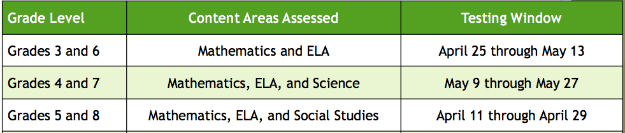

There are several websites that may be helpful to families to provide additional information about the M-STEP.
- www.mi.gov/mstep The Department of Education website for M-STEP information
- Online testing tutorials for students
- Overview of the M-STEP test in ELA and Math

We have worked hard to prepare our staff and students for this year’s M-STEP assessment. We are confident that students will perform at a high level, and will do their best during all testing sessions. If you have any questions regarding the M-STEP assessment, please feel free to contact me.

Sincerely,

Stephen, Zielinski, Principal

