

Announcing the: **Downriver Parenting Institute**

**“*Helping Children Become Successful Learners*”**

**Free Workshop Series for Parents and Teachers*!***

We all want our children to be healthy, successful and ready to succeed! Parenting is a challenging job from beginning to end. Please use this **FREE** workshop to fine tune your parenting skills.

**We Invite all downriver parents and teachers** of children ages 2-12, to join us for this **FREE** workshop series being presented by Bob Sornson, Ph.D. Bob is an internationally recognized author, trainer, speaker, and founder of the Early Learning Foundation. This workshop series will be held in Wyandotte and you will find complete details when you register. Light refreshments will be provided but childcare will not.

**Helping Children Become Successful Learners** (4 sessions) 6:30 p.m. to 8:30 p.m.

**Tuesday, May 10th, May 17th, Thursday May 19th, and Tuesday, May 24th**

**Please Register for this Free workshop by logging onto:**

[**www.facebook.com/DownriverParentingInstitute**](http://www.facebook.com/DownriverParentingInstitute)

and click the **Apply today** box. Seating is limited and each parent or teacher needs to register. In addition to the workshop you will have access to additional resources (a lending library, a private FB page and a website with more content).

Questions? Please email: [feedback@DownriverParentingInstitute.org](mailto:feedback@DownriverParentingInstitute.org) or call 734-225-6616.

**Please Share with family, friends and colleagues!**

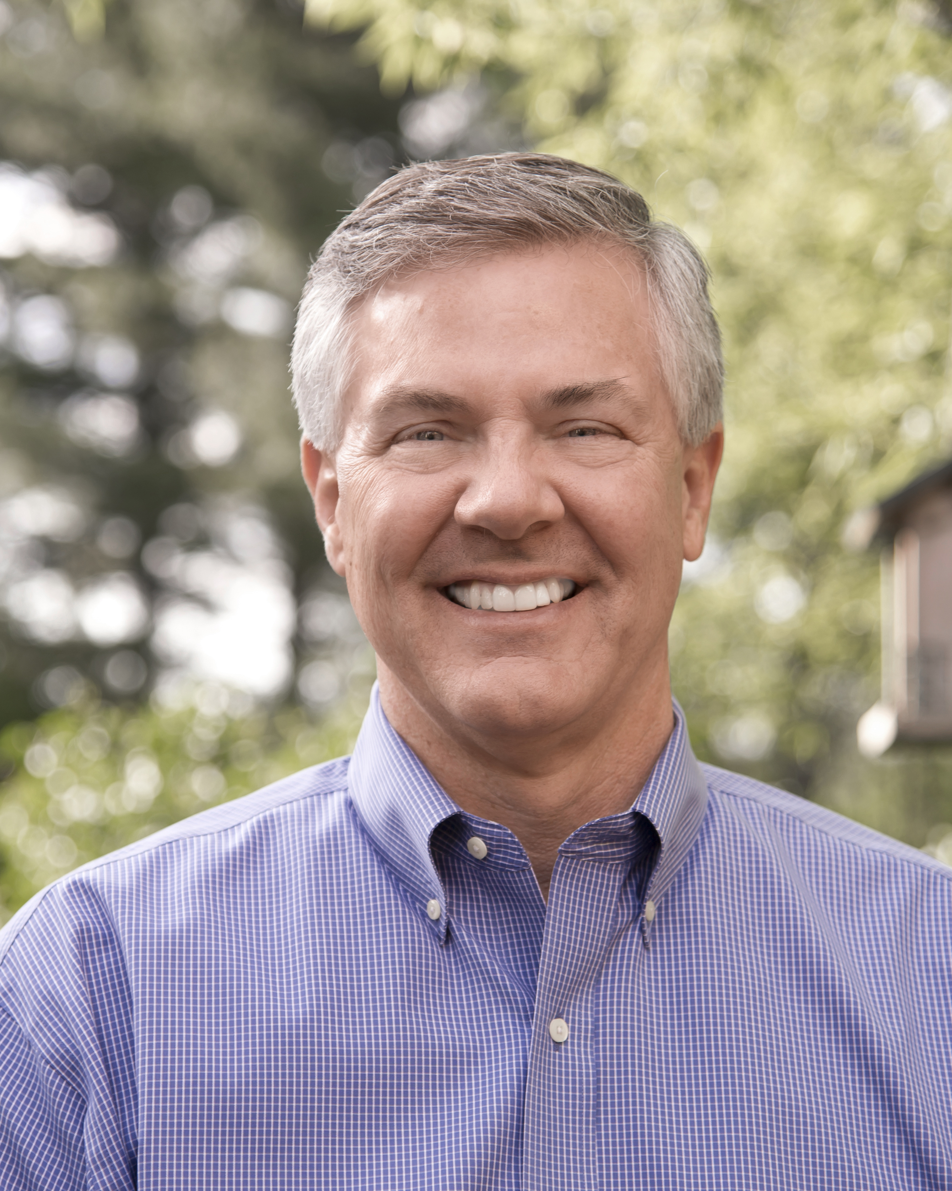 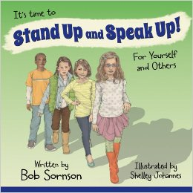 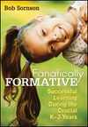

Bob Sornson, Ph.D.