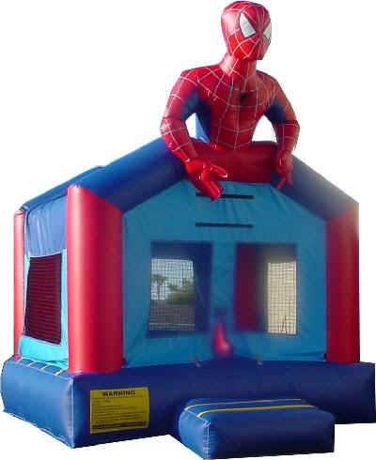****

We have an amazing night planned for you and your son! We have rented multiple types of bounce houses and inflatables for you to enjoy! We will be serving dinner at the event! We will also have an amazing photographer on hand to capture the moment!

Please RSVP no later than November 16th.

Any questions or concerns please contact arnopta@gmail.com.

Student Name: ________________________________ Grade: ______________

Teacher Name: ________________________________

Number of people attending: ___________ Amount: ________

**Do you have a son that you love spending time with? Do you have a hard time finding things that you both will enjoy doing?**

**Then look no further!!! Come join us for a night of food and fun!!!**

**When:** Thursday, November 17, 2006 @ 6pm

**Where:**  Allen Park Civic Center Gym

**Why:** To enjoy some quality time with your son! We will be bouncing the night away and enjoying some wonderful food!!!

**Cost:** $25 per couple $10 per additional son

**Mother Son Night**