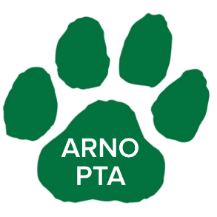
Are you looking for a fun activity for your family to do over the long holiday break??
FAMILY FUN
We have just the solution for you!!!!
Arno PTA has joined with Roosevelt Lanes to bring you a night of family fun!
December 27th from 3-6pm
$11 per person
3 hours of bowling
2 slices of pizza & pop
Shoe Rental included in price
Bring the entire family (except the 4 legged ones) to share in this fun event!!!
Please RSVP by the 20th! Due to planning a big event this will be a firm date.
If you have any questions, please feel free to email arnopta@gmail.com
__________________________________________________________
Student Name: _______________________ Teacher: _______________
Amount Enclosed: ______________________

