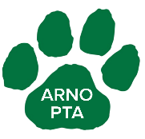
Who likes to save money AND support their school and child's PTA???
Caring Cougars Do!!!
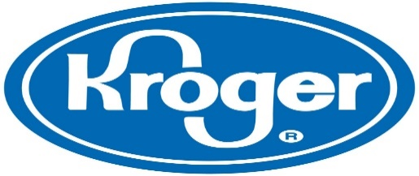
We have TWO (that's right, 2!) new programs that you can use to help out your PTA! Simple and easy to sign up and that's all you need to do! The Organizations do the rest for you! Sign up today and let's start earning more rewards for our kids!
Thank you!
TO USE THE KROGER COMMUNITY REWARDS PROGRAM:
- Register your card online at www.krogercommunityrewards.com if you haven’t already.
- Click on Sign In/Register
  - Most participants are new online customers, so they must click on SIGN UP TODAY in the “New Customer?” box
- Sign up for Kroger Rewards Account by entering your zip code, clicking on your favorite store, entering your email address and creating a password, and agreeing to the terms and conditions
- You will then get a message to check your email inbox and click on the link within the body of the email
- Click on My Account and use your email address and password to proceed to the next step
- Click on Edit Kroger Community Rewards information and input your Kroger Plus card number.
- Update or confirm your infomration
- Enter NPO number 54361 or name of organization, select organization from list and click on Confirm
- To verify you are enrolled correctly, you will see your organization’s name on the right side of your information
- Do you use your phone number at the register? Call 877-576-7587 to get your Kroger Plus card number linked with us
- Members must swipe their registered Kroger Plus card or use the phone number that is related to their registered Kroger Plus card when shopping for each purchase to count.

TO USE AMAZON SMILE:
- Go to www.Amazonsmile.com
- A pop-up box will appear and ask you to sign in using your regular username and password.
- Once you’ve logged in, you will see a screen asking you to type in the charity of your choice. Type: ARNO ELEMENTARY PTA. Click Select
- Start Shopping!!!

