Arno Elementary School PTA
Fundraiser

A great cause
and some great food
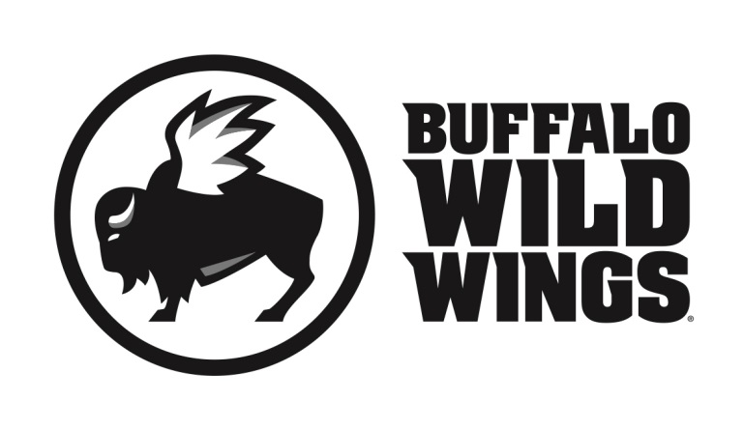

All friends, family and supporters of the Arno Elementary School PTA
are invited to participate in their fundraising event on
Wednesday, February 27, 2019

Everyone is invited to gather at Buffalo Wild Wings in Southgate (13655 Eureka Dr.) for lunch, dinner, or a snack. On this day, 20% of purchases* accompanied by the certificate below will be donated to
Arno Elementary School PTA.

Arno Elementary School PTA Fundraiser
Wednesday, February 27, 2019

Present this certificate to your server at the
time of your order and 20% of your
purchases* will go to support
Arno Elementary School PTA.
*Valid towards Dine-In and Carry-Out. Not valid towards gift card purchases. Flyers are not permitted to be distributed inside or outside the restaurant.
Only valid at 13655 Eureka Dr., Southgate, MI (734) 281-2999

