Mobile App Installation Instructions
  - MISTAR Consortium
August 15, 2019

To connect to our school district, we offer a free mobile application for your smart phone or tablet.
It is quick and easy to get started!
- On your device, connect to the Android Play store or the iOS App Store.
Look for the Q Parent Connection app, like the icon below:
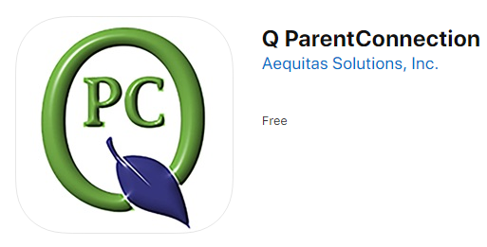
Links:
Android Q ParentConnection Apple Q Parent Connection
Android Q StudentConnection Apple Q Student Connection
- Install / Open the app.
- Select the “Connect to school district” option. Use the filter to select the state, county and school district.
- Click the “Enter Parent Connection” button.
- On the top right corner of the app, click the “Log in” button.
- Enter your Parent Portal PIN and password. These are the same PIN and passwords you may have used on a desktop computer.
Having trouble? Contact us at

